3 CASE STUDIES
« The pomp and scale » of the crown ... but not enough to keep it going.

Case study 1 : Comment on this short archive document about Princess Elizabeth’s speech in Cape Town, 1947 . https://www.youtube.com/watch?v=RUlToHE_27U
2. Historical context
3. Princess Elizabeth ‘s personality
4. Future Implications

Case Study 2 : The British Empire and the post-war period, a filmography
Give a list (about 10-15 films) of films (fiction films, not documentary films) you know and give 6 corresponding key words to describe each of them.
Example :
AFRICA
Out of Africa, 1985. Directed by Sydney Pollack, starring Meryl Streep, Robert Redford, Klaus Maria Brandauer etc. KW : Karen Blixen-Nairobi-Farm-Ngong Hills- Kikuyu people-love story

INDIA :
Gandhi, 1982. Directed by Richard Attenborough, starring Ben Kigsley, Martin Sheen, Candice Bergen, Roshan Seth, etc. KW : Indian independence- non-violence protest movement- rights- massacre- peace-national hero

IRELAND :
The Wind that shakes the Barley, 2006. Directed by Ken Loach, starring Cillian Murphy, Liam Cunningham etc. KW : Independence- paramilitary squads- struggle- Irish volunteers-1919- brothers

Webography :
https://www.britishempire.co.uk/media/silverscreen.htm
https://webhost.lclark.edu/campion/hist328/films.htm#barley
https://en.wikipedia.org/wiki/Category:Films_set_in_the_British_Empire

Case study 3, The British Empire and the Commonwealth : iconography.
Comment on these 3 different documents and say to what extent they can be liked together.
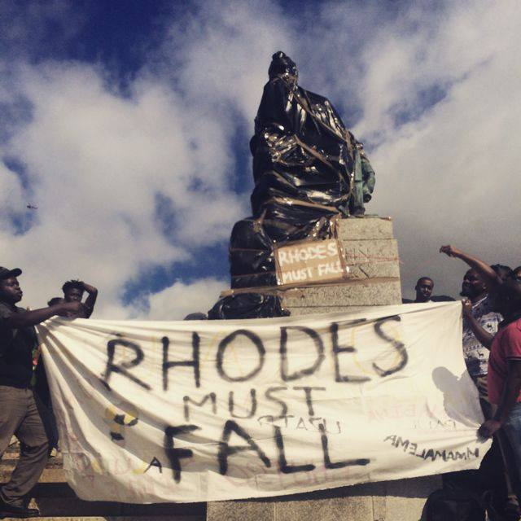
https://fourwaysreview.co.za/224270/throwback-thursday-rhodes-must-fall-movement-gallery/

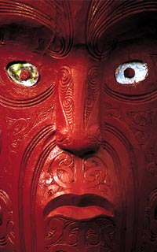
https://www.tourism.net.nz/new-zealand/about-new-zealand/maori-culture.html

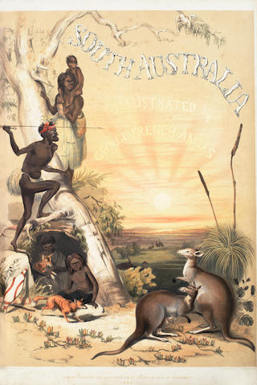
https://www.bonhams.com/auctions/23459/lot/230/

xxxxxxxxxxxxxxxxxxxxxxxxxxxxx

