Chevalley Jérémie

Eukaidoz
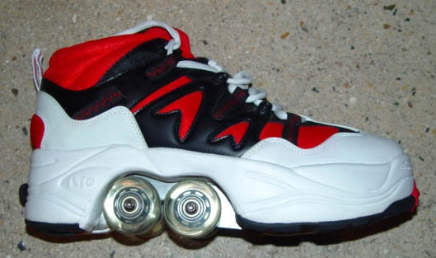

Wheel
Chip Wireless
Magnetic metal plate

- Download the free EUKAIDOZ portable application on your phone to activate the retracted and the wheels of your shoes (make sure you have an internet connection on your phone without which the deployment and turnaround wheels will not be able to perform).

- If you need to change the wheels of your shoes, you must abort them out of the base and then pull gently to what kind of course.

- If you need to change the metal plate of your shoe that can oxidize with time, you must abort disable the metallic plate through the application of your laptop after removing the wheels as explained above if, and finally pull the plate until what comes.

- If you need to change the wireless chip that is located in the heel of the shoe, send us your shoe so that we repair for them safely.

Our product is guaranteed for 2 years, you are satisfied or refund. EUKAIDOZ is a simple and effective way to move more intuitively in the life of every day, once you try it you would not be able to do without. Occurs is just as revolutionary in the way that feels used in its design. With EUKAIDOZ not walk more, ride.

