Sacagawea
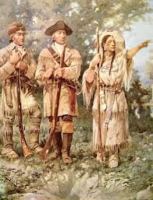
Hello my name is Sacagawea and I am a Native American woman. I am the only woman who helped Lewis and Clark on their expedition. I showed 33 men the way to the Missouri river.
My husband is a Native American chief and I have a baby boy named Pomp who was just a newborn when I was on the expedition. To get Pomp out of my belly I had to use rattle snake tail medicine that Clark gave me. To get the medicine Clark had to cut off a rattle snake tail and smashed it up into little pieces so I could eat it.
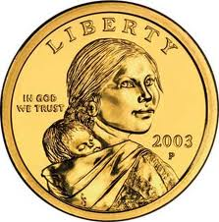
During the expedition, I collected berries and fruit for Lewis and Clark. At the end of their journey Lewis and Clark traded me a sea otter fur robe for my bleu necklace. Clark had a journal he wrote in during the journey. Lewis was born August 18th 1774 and died October 11th 1809. Clark also was born in August but on the first and died September first 1838.
There are U.S.A dollars coins with Pomp and I on them. I loved nature, horses and meeting new people. Lewis and Clark were my best friends.
People don’t agree when I died. Some people say I died when I was 25 and some people say I died when I was 96. But I say I died December 12th 1884.

The End

